# **Advanced Data Analysis using SQL**

**Amazon Brazil's Data Analysis using SQL**



**By:** Ansh Jain

**Program:** NextLeap **Data Analyst** Fellowship

**Date:** June 2025

**Table of Contents**

1. **Introduction**
   * 1.1 Leveraging Data-Driven Insights from Amazon Brazil's Data
   * 1.2 Objective
   * 1.3 Data Source
   * 1.4 Data Preparation
2. **Analysis – I**
   * Q 2.1 Standardizing Payment Values
   * Q 2.2 Payment Type Distribution
   * Q 2.3 Smart Products in Price Range
   * Q 2.4 Top 3 Sales Months
   * Q 2.5 Categories with High Price Variations
   * Q 2.6 Payment Type Consistency Analysis
   * Q 2.7 Products with Incomplete Category Names
3. **Analysis – II**
   * Q 3.1 Payment Type Popularity Across Order Value Segments
   * Q 3.2 Product Category Price Analysis
   * Q 3.3 Multi-Order Customers
   * Q 3.4 Customer Categorization
   * Q 3.5 Top Revenue Generating Categories
4. **Analysis – III**
   * Q 4.1 Seasonal Sales Comparison
   * Q 4.2 Above-Average Sales Volume Products
   * Q 4.3 Monthly Revenue Trends for 2018
   * Q 4.4 Customer Segmentation Using CTE
   * Q 4.5 Top 20 High-Value Customers
   * Q 4.6 Monthly Cumulative Sales Using Recursive CTE
   * Q 4.7 Month-over-Month Growth Rate Analysis

**1. Introduction**

**1.1 Leveraging Data-Driven Insights from Amazon Brazil's Data:**

Amazon, a global e-commerce leader, has demonstrated tremendous success in emerging markets like Brazil by connecting local businesses with millions of customers. With similar market characteristics—large population, diverse consumer behaviours, and a growing digital economy—India represents a strong opportunity for replicating this success.

By analysing transactional data from Amazon Brazil, we can uncover customer behaviours, product trends, and operational metrics that can be adapted for strategic growth in the Indian market. This project leverages the comprehensive dataset from Amazon Brazil to inform Amazon India's strategic initiatives using advanced SQL-driven analysis.

**1.2 Objective:**

The objective of this analysis is to understand and analyse:

* **Customer demographics and behaviours** using the Customers table to understand purchase patterns and preferences
* **Evaluate regional trends** and customer density through geographical data analysis
* **Track order lifecycles** and product preferences using Orders, Order Items, and Product tables
* **Analyze payment preferences** and transaction details via the Payments table
* **Identify seasonal patterns** and revenue optimization opportunities
* **Segment customers** based on purchasing behavior for targeted marketing strategies

This comprehensive analysis will help Amazon India enhance customer experience, optimize operations, and seize new market opportunities through data-driven decision making.

**1.3 Data Source:**

The analysis is based on a relational dataset from Amazon Brazil consisting of **6 interconnected tables** that provide comprehensive insights into e-commerce operations:

* **Customers:** Customer unique identifiers, geographical locations, and demographic segmentation data
* **Orders:** Order timestamps, delivery status, customer linkages, and order lifecycle information
* **Order Items:** Item-level transaction details including product IDs, prices, shipping costs, and seller information
* **Products:** Product catalog data including category names, descriptions, and physical attributes
* **Sellers:** Seller identification, location data, and marketplace participation details
* **Payments:** Payment method preferences, transaction values, installment details, and financial data

The dataset spans multiple years of transactional data, providing rich insights into customer behavior, seasonal trends, and business performance metrics.

**1.4 Data Preparation:**

Data was imported into **PostgreSQL** using CSV files and organized into a dedicated schema for comprehensive analysis. The analysis employs a wide range of advanced SQL techniques including:

* **Fundamental SQL Operations:** SELECT, WHERE, GROUP BY, ORDER BY clauses
* **Aggregate Functions:** SUM, COUNT, AVG, MIN, MAX, STDDEV
* **Advanced Joins:** INNER JOIN, LEFT JOIN for multi-table analysis
* **Window Functions:** RANK, DENSE_RANK, LAG, ROW_NUMBER, partitioning
* **Common Table Expressions (CTEs):** Both standard and recursive CTEs
* **Subqueries:** Nested queries for complex analytical requirements
* **Date-Time Operations:** Seasonal analysis, monthly trends, and time-based segmentation

**SCHEMA**

The analysis is strategically divided into **3 comprehensive parts** covering different business aspects, with a total of **19 practical business questions**. Each question addresses real-world scenarios relevant to Amazon India's market entry and growth strategy, from basic descriptive analytics to advanced predictive insights.

*This analysis translates raw relational data into actionable business intelligence, providing Amazon India with the insights needed to replicate Amazon Brazil's success in the Indian market.*

**2. Analysis – I**

**Question 2.1 -- Standardizing Payment Values**

**Problem Statement:**

-To simplify its financial reports, Amazon India needs to standardize payment values. The finance team requires payment analysis with rounded average values to eliminate decimal complexities and create cleaner reporting dashboards. This standardization will help in budget planning and payment method comparison across different transaction volumes.

**Desired Output:**payment_type, rounded_avg_payment

**SQL Query:**

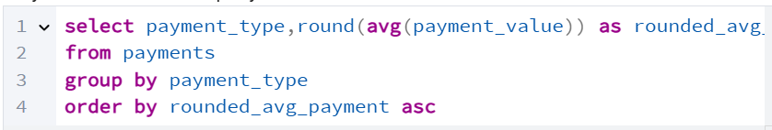

**Query Output:**

**Recommendations:**

**Strategic Payment Optimization for Amazon India:**

1. Premium Payment Channel Focus: Since credit cards show the highest average transaction values (165 BRL), Amazon India should prioritize credit card adoption through:
   * Exclusive EMI options with 0% interest for high-value purchases
   * Additional cashback rewards (2-3%) for credit card transactions
   * Premium customer service for credit card users
2. Voucher-Based Customer Retention: With vouchers showing the second-highest average values (158 BRL), implement:
   * Loyalty voucher programs for repeat customers
   * Category-specific vouchers for high-margin products
   * Seasonal voucher campaigns during peak sales periods

**Question 2.2 -- Payment Type Distribution**

**Problem Statement:**

To refine its payment strategy, Amazon India wants to understand the distribution of orders by payment type. The marketing team needs percentage-based insights to determine which payment methods are most popular among customers, enabling them to optimize payment gateway partnerships and promotional strategies.

**Desired Output:**payment_type, percentage_orders

**SQL Query:**

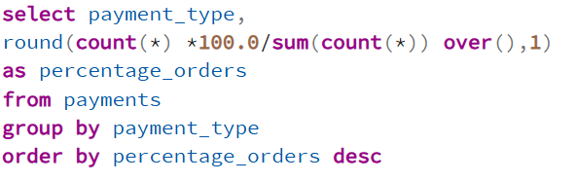

**Query Output:**

**Recommendations:**

**Payment Infrastructure Prioritization for Amazon India:**

1. Credit Card Infrastructure Investment: With 74% usage rate, ensure robust credit card processing capabilities, multiple gateway partnerships, and instant approval systems.
2. Boleto-Equivalent Strategy: Since Boleto captures 19% of transactions in Brazil (serving unbanked population), Amazon India should develop UPI, cash-on-delivery, and digital wallet partnerships to capture India's similar demographic**.**

**Question 2.3 -- Smart Products in Price Range**

**Problem Statement:**

Amazon India seeks to create targeted promotions for products within specific price ranges. The product team wants to identify all "Smart" products priced between 100 and 500 BRL to develop focused marketing campaigns for tech-savvy customers in the mid-range segment.

**Desired Output:**product_id, price

**SQL Query:**

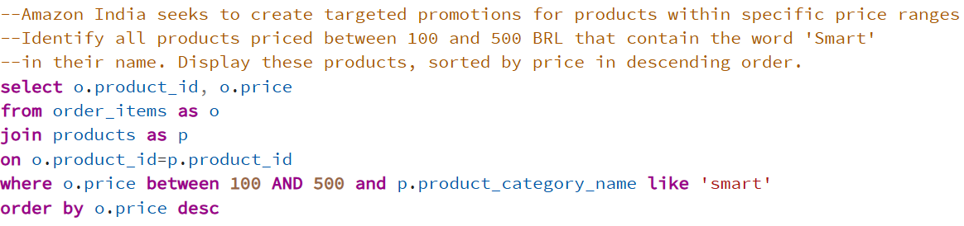

**Query Output:**

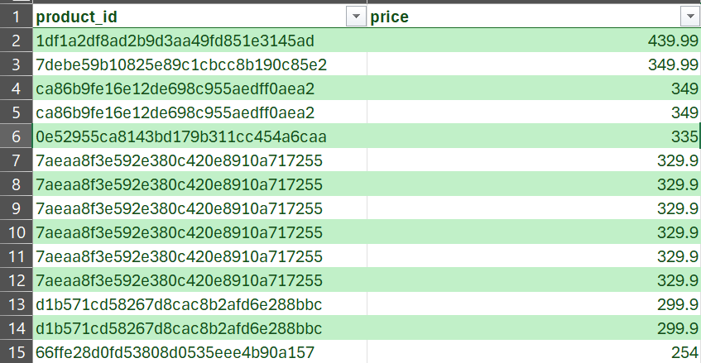

**Recommendations:**

***Smart Product Category Marketing Strategy for Amazon India:***

1. ***"Affordable Smart Living" Brand Positioning:*** *Position the 100-500 BRL price range as the "smart and affordable" segment, targeting middle-income consumers who aspire for technology without premium pricing.*
2. ***Social Media-Driven Marketing Campaigns:***
   * *Create influencer partnerships showcasing smart products as lifestyle essentials*
   * *Develop "Smart Home on a Budget" content series across Instagram, YouTube, and regional platforms*
   * *Use before/after demonstrations to highlight product value*
3. ***Category Expansion:*** *Use successful smart products as anchor items to introduce customers to higher-value smart home ecosystems, creating natural upselling opportunities.*

**Question 2.4 --Top 3 Sales Months**

**Problem Statement:**

To identify seasonal sales patterns, Amazon India needs to focus on the most successful months. The operations team requires insights into peak sales periods to optimize inventory management, staffing levels, and marketing spend allocation throughout the year.

**Desired Output:**month, total_sales

**SQL Query:**

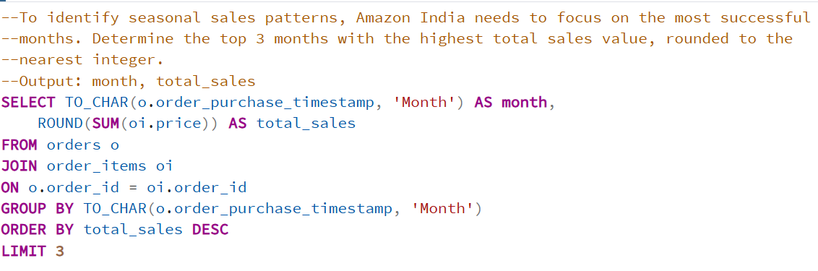

**Query Output:**

**Recommendations:**

***Seasonal Sales Optimization Strategy for Amazon India:***

1. ***Pre-Peak Marketing Amplification:***
   * ***October (Pre-November):*** *Launch Diwali/festive season campaigns with 40% increased marketing spend*
   * ***April (Pre-May):*** *Target summer product categories with early-bird promotions*
   * ***July (Pre-August):*** *Focus on back-to-school and monsoon-ready products*
2. ***Category-Specific Seasonal Targeting:***
   * ***November:*** *Electronics, home appliances, and gift items (leveraging festive demand)*
   * ***May:*** *Summer essentials, travel gear, and cooling appliances*
   * ***August:*** *Fashion, back-to-school supplies, and monsoon products*
3. ***Credit Card Partnership Expansion (Leveraging 74% Usage Rate):***
   * *Partner with major Indian banks (HDFC, ICICI, SBI) for exclusive seasonal offers*
   * *Introduce 0% EMI options for purchases above ₹10,000 during peak months*
   * *Launch "Buy Now, Pay Later" services specifically timed with high-sales periods*
4. ***Anchoring Product Strategy:***
   * *Offer steep discounts (20-30%) on high-demand anchor products to drive traffic*
   * *Create "End-of-Season" clearance events to maintain momentum between peak periods*
   * *Use seasonal anchor products to cross-sell complementary higher-margin items*

**Question 2.5 --Categories with High Price Variations**

**Problem Statement:**

Amazon India is interested in product categories with significant price variations. The pricing strategy team needs to identify categories where the difference between maximum and minimum product prices exceeds 500 BRL. This analysis will help understand market dynamics, pricing opportunities, and potential for premium vs. budget product positioning within categories.

**Desired Output:**product_category_name, price_difference

**SQL Query:**

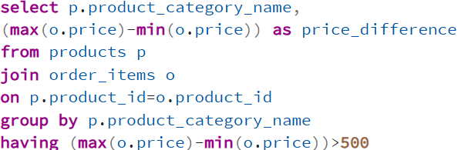

**Query Output:**

**Recommendations:**

***Quality-Controlled Product Range Management for Amazon India:***

1. ***Dynamic Quality-Price Monitoring System:***
   * *Implement automated alerts for products priced >60% below category average*
   * *Establish mandatory quality verification for products in bottom 10% price range*
   * *Create real-time dashboard tracking correlation between low prices and negative reviews*
2. ***Seller Performance Management:***
   * ***Warning System:*** *Issue quality alerts to sellers with products receiving <3.5 star ratings in low-price segments*
   * ***Seller Education:*** *Provide training on maintaining quality standards while offering competitive pricing*
   * ***Progressive Penalties:*** *Implement 3-tier system - Warning → Product delisting → Seller suspension for persistent quality issues*
3. ***Category-Specific Price Band Strategy:***
   * *Create "Amazon's Choice" badges for products offering optimal price-quality balance*

**Question 2.6 -- Payment Type Consistency Analysis**

**Problem Statement:**

To enhance the customer experience, Amazon India wants to find which payment types have the most consistent transaction amounts. The finance team needs to identify payment methods with the least variance in transaction amounts to understand customer behavior patterns and optimize payment processing systems.

**Desired Output:**payment_type, std_deviation

**SQL Query:**

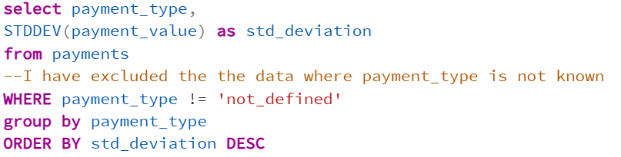

**Query Output:**

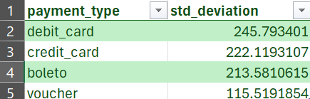

**Recommendations:**

**Payment Predictability Strategy for Amazon India:**

1. **Cash Flow Forecasting Optimization:** Use payment methods with low standard deviation (high consistency) for accurate revenue predictions and inventory planning, while accounting for higher variability in inconsistent payment channels.
2. **Targeted Product Positioning:** Position consistent-value products (daily essentials, subscriptions) toward payment methods showing predictable transaction patterns, while promoting high-value/variable items through payment channels with higher transaction variance.

**Question 2.7 -- Products with Incomplete Category Names**

**Problem Statement:**

Amazon India wants to identify products that may have incomplete category names in order to fix data quality issues from their end. The data management team needs to find products where category information is missing or contains only a single character, which could indicate data entry errors or incomplete product catalog information.

**Desired Output:**product_id, product_category_name

**SQL Query:**

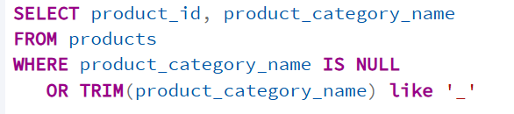

**Query Output:**

**Recommendations:**

***Data Quality Enhancement Strategy for Amazon India:***

1. ***Automated Data Validation System:*** *Implement rule-based data checks during product upload that flag incomplete or invalid category entries (e.g., NULL or single-character categories). Prevent products from going live until validated.*
2. ***Regular Data Audits:*** *Schedule weekly scans of the product catalog to identify and report any anomalies in category naming. Maintain logs for compliance and seller accountability.*
3. ***Seller Training & Enforcement:*** *Provide sellers with clear guidelines for category naming conventions. For repeated violations, issue warnings followed by listing suspension to maintain catalog integrity.*

**🔚 End of Analysis I**

**Summary of Analysis I:**

* **Q2.1:** Financial standardization for cleaner reporting
* **Q2.2:** Payment method popularity distribution analysis
* **Q2.3:** Targeted product identification for promotions
* **Q2.4:** Seasonal sales pattern recognition
* **Q2.5:** Category pricing strategy insights
* **Q2.6:** Payment consistency for user experience optimization
* **Q2.7:** Data quality improvement identification

**Key Business Value:** This section provides foundational insights into payment behaviors, product positioning, seasonal trends, and data quality - essential for Amazon India's market entry strategy.

**3. Analysis – II**

**Question 3.1 -- Payment Type Popularity Across Order Value Segments**

**Problem Statement:**

Amazon India wants to understand which payment types are most popular across different order value segments. The business strategy team needs insights into customer payment preferences based on their spending patterns - whether low-value, medium-value, or high-value customers prefer different payment methods. This segmentation will help optimize payment gateway partnerships and targeted promotions.

**Desired Output:**order_value_segment, payment_type, count

**SQL Query:**

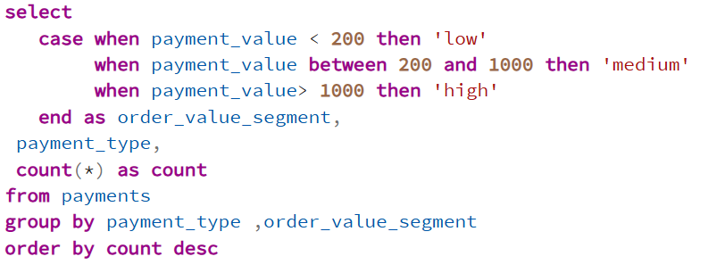

**Query Output:**

**Recommendations:**

**Segmented Payment Strategy for Amazon India:**

1. **Low-Value Segment (Under 200 BRL):**
   * **Bundle & Pay-Later Offers:** Encourage multi-item purchases by offering discounts on product bundles with pay-later options.
   * **UPI/Digital Wallet Discounts:** Provide added incentives for prepaid methods to increase digital adoption and reduce COD-related issues.
   * **Return Suppression Discount:** Offer 5% discount to customers who opt out of returns/exchanges on low-cost items to reduce logistics and fraud costs.
2. **Medium Segment (200–1000 BRL):**
   * **Anchor Product Promotion:** Identify and promote "must-have" mid-range products (e.g., daily-use electronics or lifestyle items) to upgrade low-segment buyers and boost average order value.
   * **Balanced Incentive Strategy:** Maintain a mix of credit card and digital wallet offers while using customer insights to deliver personalized nudges toward mid-tier purchases.
3. **High-Value Segment (Above 1000 BRL):**
   * **Voucher Optimization:** Reduce reliance on vouchers and shift focus to advance payment methods like UPI for better cash flow.
   * **Enhanced EMI Offerings:** Expand partnerships with banks to offer flexible EMI and “Buy Now, Pay Later” options during seasonal promotions.

**Question 3.2 --Product Category Price Analysis**

**Problem Statement:**

Amazon India wants to analyse the price range and average price for each product category. The pricing strategy team requires comprehensive insights into minimum, maximum, and average prices across all categories to inform competitive pricing strategies, identify premium vs. budget segments, and optimize category-specific promotions.

**Desired Output:**product_category_name, min_price, max_price, avg_price

**SQL Query:**

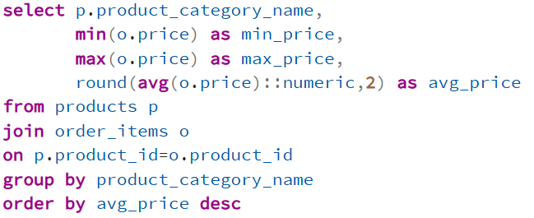

**Query Output:**

**Recommendations:**

**Category-Based Pricing Rationalization Strategy for Amazon India:**

1. **Price Floor Enforcement:**  
   For categories with extreme price differences, establish a **minimum pricing threshold** for products with similar specifications. This prevents ultra-low-cost listings that may harm platform trust and create unfair competition.
2. **Segmented Product Categorization:**  
   Define clear price bands within each category (e.g., Budget, Mid-range, Premium). This improves customer navigation, simplifies recommendation systems, and supports targeted marketing.
3. **Increase Average Order Value (AOV):**  
   By minimizing disruptive pricing gaps, Amazon can drive customers toward mid-tier and premium items, resulting in higher average order value and improved seller margins — without compromising on variety.

**Question 3.3 -- Multi-Order Customers**

**Problem Statement:**

Amazon India wants to identify customers who have placed multiple orders over time. The customer retention team needs to understand repeat purchase behavior to develop targeted loyalty programs, personalized recommendations, and retention strategies for customers who demonstrate ongoing engagement with the platform.

**Desired Output:**customer_unique_id, total_orders

**SQL Query:**

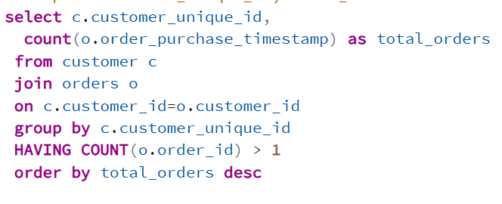

**Query Output:**

**Recommendations:**

**Loyalty & Influencer Strategy for Multi-Order Customers:**

1. **Loyalty Recognition Program:**Identify customers with high order counts and reward them with exclusive hampers including personalized vouchers, product samples, and thank-you gifts to deepen trust and brand attachment.
2. **Social Proof Marketing Loop:**Promote videos or testimonials from these loyal users receiving their rewards, and showcase them to occasional buyers to inspire more frequent purchases and create aspiration.
3. **Behavioral Personalization & Brand Collaborations:**Analyze product categories purchased, return rates, and seasonal trends for each loyal customer. Use this data to personalize gifts and include sponsored samples from premium brands — creating win-win marketing for both Amazon and its partners.

**Question 3.4 -- Customer Categorization**

**Problem Statement:**

Amazon India wants to categorize customers into different types based on their purchase history. The marketing team needs to segment customers as 'New' (1 order), 'Returning' (2-4 orders), or 'Loyal' (>4 orders) to develop targeted marketing campaigns, personalized offers, and retention strategies appropriate for each customer lifecycle stage.

**Desired Output:**customer_unique_id, customer_type

**SQL Query:** 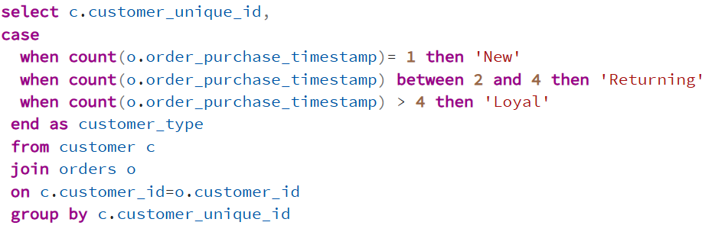

**Query Output:**

**Recommendations:**

**Customer Lifecycle Marketing Strategy for Amazon India:**

1. **New Customers – Build Trust & Belonging:**  
   Thank first-time buyers with personalized notes and offer "Early Bird" discounts on low-to-mid range products. Request feedback 3 days post-delivery to make them feel heard and valued.
2. **Returning Customers – Create Habitual Engagement:**  
   Launch subscription models for frequently purchased categories (like groceries), and increase targeted vouchers to drive deeper browsing and platform stickiness.
3. **Loyal Customers – Drive Category Expansion:**  
   Encourage purchases in new product categories by offering curated suggestions and exclusive deals. Use data to personalize these nudges for maximum relevance and discoverability

**Question 3.5 -- Top Revenue Generating Categories**

**Problem Statement:**

Amazon India wants to know which product categories generate the most revenue. The business development team needs to identify the top 5 revenue-generating categories to prioritize inventory investments, supplier relationships, marketing spend allocation, and category management resources for maximum ROI.

**Desired Output:**product_category_name, total_revenue

**SQL Query:**

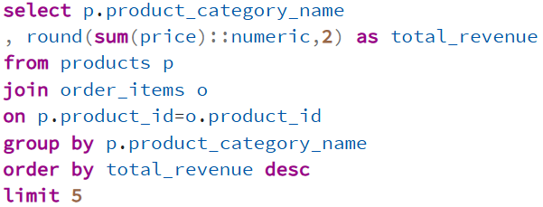

**Query Output:**

**Recommendations:**

**Strategic Category Development for Revenue Maximization:**

1. **Seller Relationship Strengthening:**Prioritize engagement with top sellers in high-revenue categories through better margins, account management, and exclusive visibility benefits to retain and scale their presence.
2. **Amazon’s Choice Labeling Strategy:**Promote high-performing, highly rated products under the “Amazon’s Choice” label to boost trust and conversion. Charge sellers a small platform fee in exchange for increased visibility and credibility.

**🔚 End of Analysis II**

**Summary of Analysis II:**

* **Q3.1:** Payment preferences across spending segments for targeted financial strategies
* **Q3.2:** Comprehensive category pricing analysis for competitive positioning
* **Q3.3:** Multi-order customer identification for retention programs
* **Q3.4:** Customer lifecycle segmentation for personalized marketing
* **Q3.5:** Revenue-focused category prioritization for business growth

**4. Analysis -- III**

**Question 4.1 -- Seasonal Sales Comparison**

**Problem Statement:**

Amazon India wants to compare sales performance across different seasons to optimize seasonal marketing campaigns and inventory management. The operations team needs to understand which seasons drive the highest sales volumes to allocate resources effectively and plan seasonal promotions, particularly important for the Indian market with its distinct festival seasons.

**Desired Output:** season, total_sales, avg_monthly_sales

**SQL Query:**

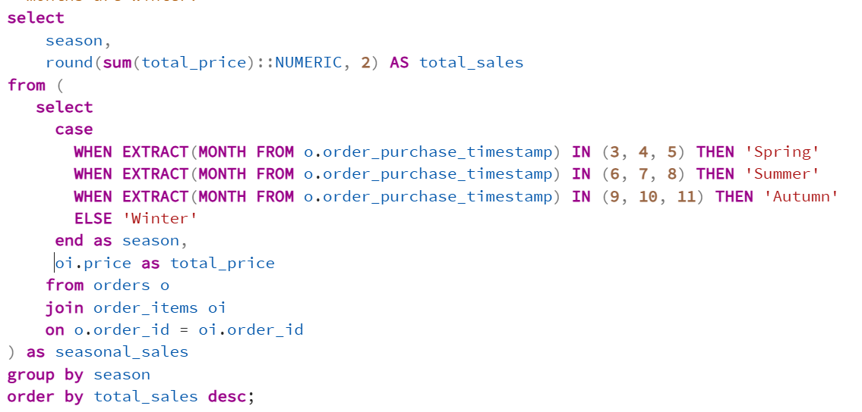

**Query Output:**

**Recommendations:**

**Seasonal Category-Driven Sales Strategy for Amazon India:**

1. **Seasonal Deep-Dive Campaigns:**  
   Align promotional focus with seasonal needs — e.g., school/college reopening essentials in summer, winter wear in Q4, monsoon essentials in mid-year.
2. **Early Campaign Launches:**  
   Begin promotions 2–3 weeks ahead of seasonal peaks to capture early demand. Bundle items (e.g., electronics with accessories) to boost AOV.
3. **Cross-Seasonal Voucher Strategy:**  
   Offer winter-specific vouchers to summer buyers to ensure off-season engagement and platform retention.

**Question 4.2 -- Above-Average Sales Volume Products**

**Problem Statement:**

Amazon India wants to identify products that consistently perform above the average sales volume. The inventory management team needs to recognize high-performing products to ensure adequate stock levels, negotiate better supplier terms, and prioritize these products in marketing campaigns to maximize revenue potential.

**Desired Output:** product_id, product_category_name, total_quantity_sold

**SQL Query:**

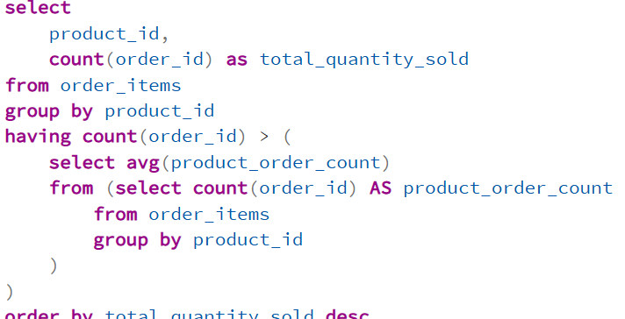

**Query Output:**

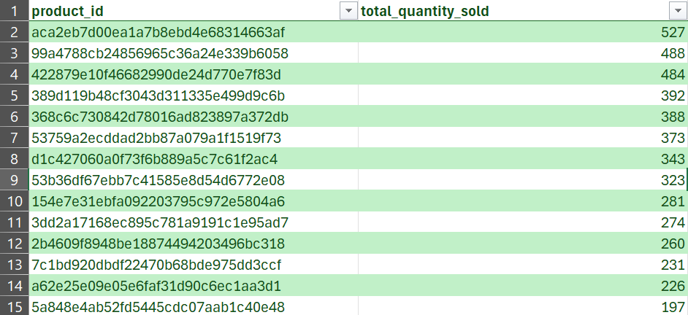

**Recommendations:**

**High-Volume Product Promotion & Bundling Strategy:**

1. **Preferred Product Promotion:**  
   Feature high-sale items in “Liked by Others” sections to increase trust-based conversion.
2. **Seller Incentivization & Price Harmonization:**  
   Reward top-selling product sellers with better margins while controlling price variability to push buyers toward the recommended listings.
3. **Smart Bundling Strategy:**  
   Bundle accessories or add-ons (e.g., phone covers with mobiles) based on customer behavior and offer them together with a slight discount. Take a convenience cut from sellers on bundled transactions.

**Question 4.3 -- Monthly Revenue Trends for 2018**

**Problem Statement:**

Amazon India wants to analyze monthly revenue trends for 2018 to understand business growth patterns and identify peak performance periods. The finance team needs detailed month-by-month revenue analysis to inform budgeting, forecasting, and strategic planning for similar growth trajectories in the Indian market.

**Desired Output:** month, revenue_2018

**SQL Query:**

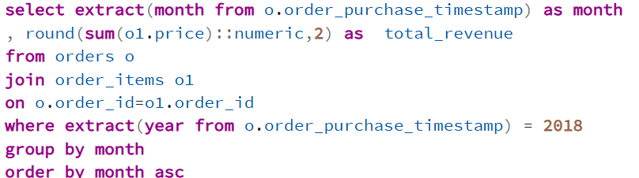

**Query Output:**

**Recommendations:**

**Seasonal Demand Balancing Strategy for Amazon India:**

1. **Winter-Ready Product Onboarding:**  
   Onboard sellers offering products relevant to slower months (e.g., winter wear, skincare, heaters).
2. **Seller Enablement for Seasonality:**  
   Train sellers to tag products as "winter-ready" and give seasonal discounts during off-peak months.
3. **Voucher Rollover Campaign:**  
   Give customers vouchers during summer that are only redeemable in winter, ensuring cyclical engagement.

**Question 4.4 -- Customer Segmentation Using CTE**

**Problem Statement:**

Amazon India wants to create advanced customer segmentation using Common Table Expressions (CTE) to categorize customers based on their total order frequency. The marketing team needs sophisticated customer segments to develop targeted campaigns, personalized recommendations, and tiered loyalty programs that match customer value and engagement levels.

**Desired Output:** customer_type,count

**SQL Query:**

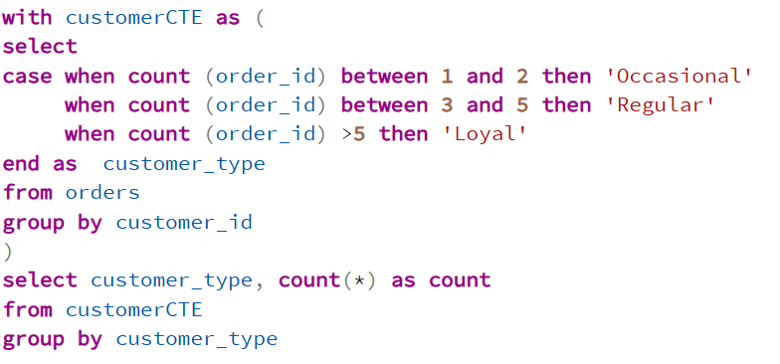

**

**Recommendations:**

**Community-Driven Loyalty Acceleration Strategy:**

1. **Amazon Loyalty Club:**  
   Organize an annual offline/virtual event for top loyal and regular customers. Provide product previews, direct team interaction, and loyalty gifts.
2. **Guest Invitations for Occasional Buyers:**  
   Invite high-value occasional buyers as “guests,” inspiring aspirational loyalty.
3. **Influencer & Brand Partnership Integration:**  
   Include product samples from premium brands in gift bags and promote the event via influencers to maximize buzz and visibility.

**Question 4.5 -- Top 20 High-Value Customers**

**Problem Statement:**

Amazon India wants to identify its top 20 highest-value customers to develop premium customer service programs, exclusive offers, and VIP experiences. The customer success team needs to recognize these valuable customers to ensure exceptional service delivery and maximize customer lifetime value through personalized attention.

**Desired Output:** customer_unique_id, total_revenue, total_orders, avg_order_value

**SQL Query:**

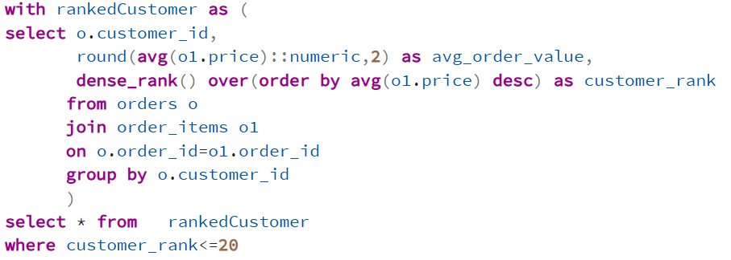

**Query Output:**

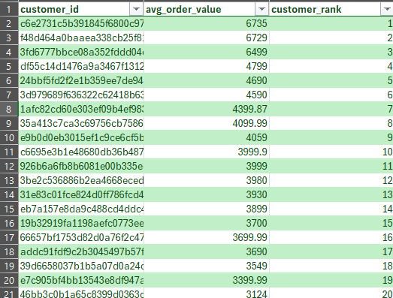

**Recommendations:**

**Premium Loyalty Experience for High-Value Customers:**

1. **Exclusive Gratitude Package:**  
   Send thank-you notes and ₹10,000 vouchers for future use, reinforcing appreciation and retention.
2. **Priority Access & Extra Discounts:**  
   Provide early access to major sales and 10% off high-margin products to reward loyalty.
3. **Festive Gift Hamper:**  
   Include branded gifts worth ₹500–₹1000 during Diwali, New Year, etc., to enhance emotional connection and encourage continued purchases.

**Question 4.6 -- Monthly Cumulative Sales Using Recursive CTE**

**Problem Statement:**

Amazon India wants to track monthly cumulative sales growth using recursive Common Table Expressions (CTE) to understand business momentum and growth acceleration. The executive team needs to visualize how sales build up over time to assess business trajectory, identify inflection points, and make strategic decisions about expansion timing.

**Desired Output:** month_year, monthly_sales, cumulative_sales

**SQL Query:**

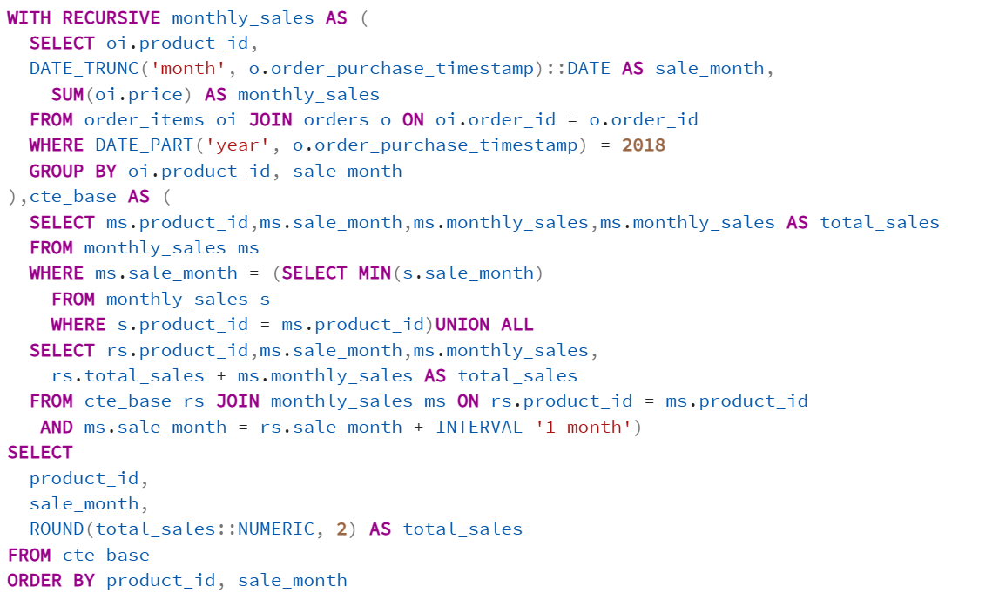

**Query Output:**

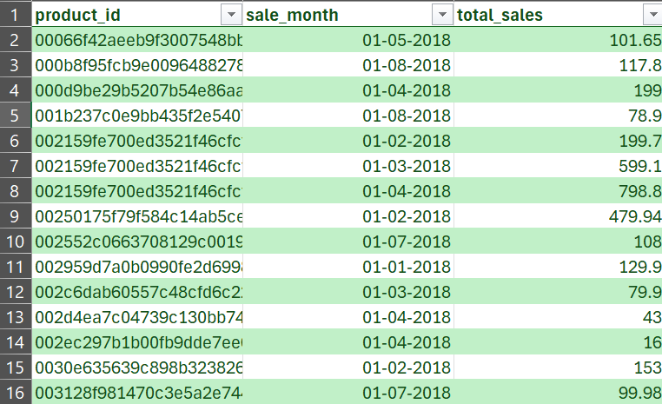

**Recommendations:**

**Momentum-Based Sales Acceleration Strategy:**

1. **Sustain Growth of High-Selling Items:**  
   Promote products with cumulative momentum into subsequent months via banners, emails, and homepage placement.
2. **Seller Performance Incentives:**  
   Offer sellers of growing products visibility perks and bonuses to ensure inventory readiness.
3. **Sales Dip Recovery Plans:**  
   During low-growth months, offer pay-later schemes, deep discounts, and exclusive bundles to maintain sales momentum.

**Question 4.7 -- Month-over-Month Growth Rate Analysis**

**Problem Statement:**

Amazon India wants to calculate month-over-month growth rates to measure business acceleration and identify trends in sales performance. The analytics team needs to understand growth velocity, seasonal impacts, and momentum changes to optimize strategic planning, resource allocation, and performance forecasting for sustained growth.

**Desired Output:** month_year, current_month_sales, previous_month_sales,

growth_rate_percentage

**SQL Query:**

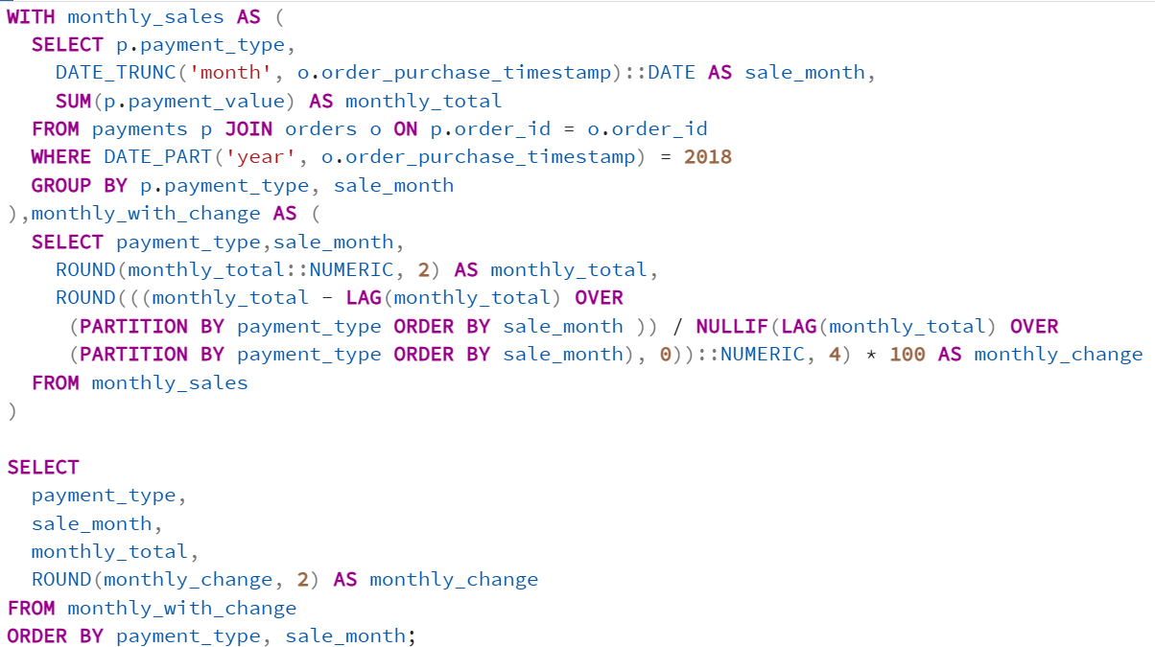

**Query Output:**

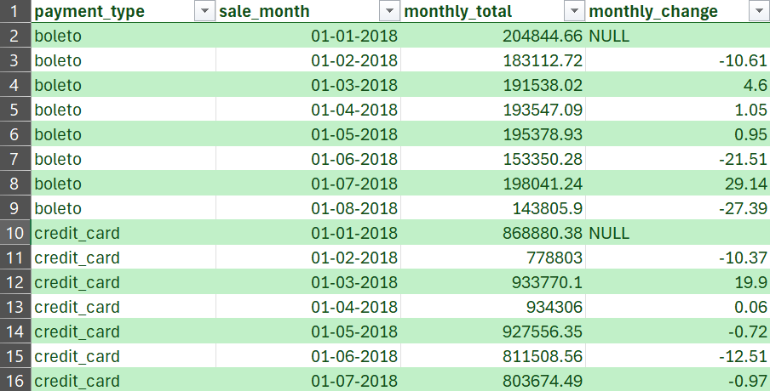

**Recommendations:**

**Month-over-Month Growth Optimization Strategy:**

1. **Early Detection of Sales Slumps:**  
   Use MoM dips as signals for flash sales or retention campaigns in underperforming segments.
2. **Performance-Based Ad Spend Allocation:**  
   Increase ad budget on consistently growing categories; cut back on stagnating ones while testing alternatives.
3. **Momentum Milestone Marketing:**  
   Create campaigns celebrating growth milestones (e.g., "Fastest-Growing Category This Month") to build buyer confidence and urgency.

**🔚 End of Analysis III**

**Summary of Analysis III:**

* **Q4.1:** Seasonal sales comparison for strategic marketing and inventory planning
* **Q4.2:** Above-average product identification for inventory optimization
* **Q4.3:** Monthly revenue trends analysis for financial forecasting
* **Q4.4:** Advanced customer segmentation using CTEs for targeted marketing
* **Q4.5:** Top 20 high-value customer identification for VIP programs
* **Q4.6:** Cumulative sales tracking using recursive CTEs for growth monitoring
* **Q4.7:** Month-over-month growth rate analysis for performance measurement

**Key Business Value:** This section provides advanced analytical insights into seasonal patterns, customer value segmentation, growth trends, and performance metrics essential for Amazon India's strategic planning and competitive positioning.

**Overall Project Summary**

This comprehensive SQL analysis of Amazon Brazil's data provides Amazon India with actionable insights across three critical business dimensions:

**Analysis I - Foundation Insights:**

* Payment method optimization and financial standardization
* Product positioning and pricing strategies
* Seasonal trend identification and data quality management

**Analysis II - Customer Intelligence:**

* Customer behavior segmentation and retention strategies
* Category performance analysis and revenue optimization
* Payment preference patterns across customer segments

**Analysis III - Advanced Analytics:**

* Sophisticated customer value segmentation
* Growth trajectory analysis and seasonal planning
* Performance measurement and strategic forecasting